MONGODB
- Installation of Mongodb and Mongosh
- creating db
- changing from admin , local or other collections
- insert values into collections
- used commands
a. insert many
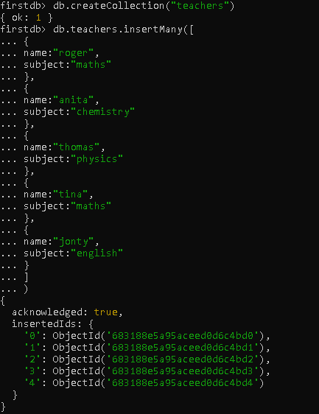
b.another example:
